To import files to the NCI ‘s Genomatix Genome Analyzer (GGA)

.bed, .bigBed or .bam alignment files that are between 2-6 GB may be uploaded via any standard, modern web browser.

Point your browser to the NCI’s GGA at:

http://ncias-729.nci.nih.gov

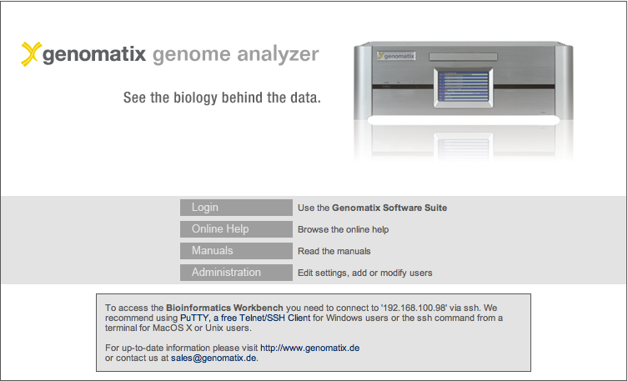

Login to the GGA server using the username and password provided to you by your local IT team (CBIIT)

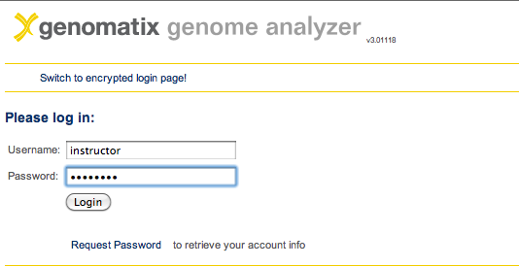

and navigate to the “Tools” tab of the Genomatix tool bar.
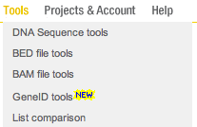

Select either BED tools or BAM tools, then Add BED (or BAM) files from your local computer. Below is an example for BED file upload:

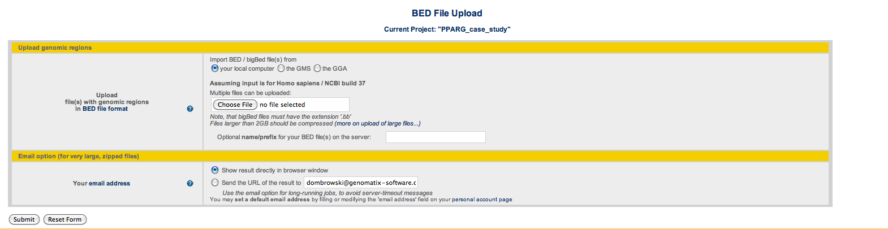

For BAM file upload, the situation is similar:

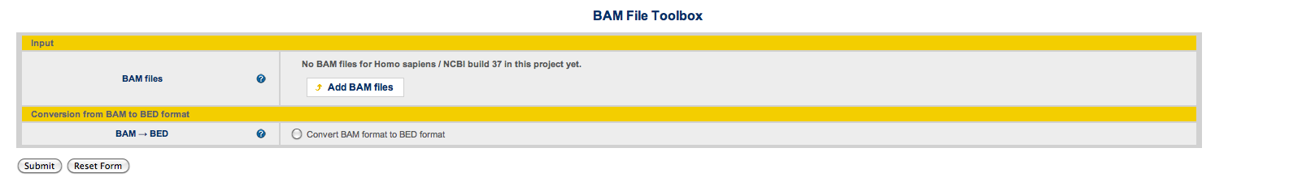

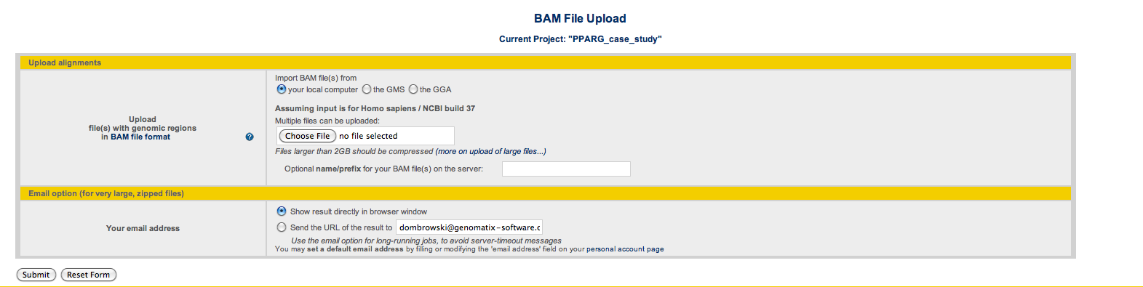

If files are GREATER than 6GB (compressed), we recommend to copy them to your home directory on the GGA,

Using the login credentials that you received from CBIIT, open a terminal window (if on a Mac or Linux machine) or Putty (if using the PC) and issue the following command:

ssh your_username @ ncias-p729.nci.nih.gov

Upon the first login, a home directory under /home will be created for you, using your login name.

Then, using either winscp (Windows), scp (Unix/Linux, if at the terminal window) or other copy utility, (e.g, Cyberduck, for the Mac) you may copy files from the remote server to the local (GGA) server. Files will automatically be placed into your home directory and can be uploaded to the GGA using the “the GGA” option on either the BAM or BED file upload pages.

NOTE: Your GGA login credentials will work in the graphical user interface (GUI) or on the commandline..

